sl.no | Device Name | Functions | Image
1 | Ethernet cable | - Connects network devices physically  - Transmits data at high speed  - Supports LAN connections | |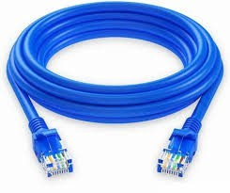
2 | Wi-fi cable | - Adds WI-FI capability to devices  - Connects to wireless networks  - Supports internet access | 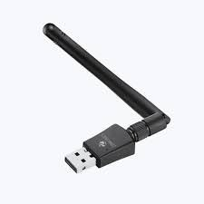
3 | Bluetooth Adapter | - Enables Bluetooth connectivity  - Connects wireless peripherals  - Used in computers and devices | 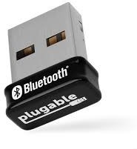
4 | Fire Wall | - Protect network from unauthorized access  - Monitors and filters network traffic  - Enhances overall network security | 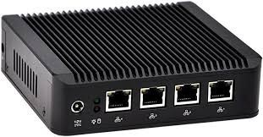
5 | Network interface card (NIC) | - Connects a computer to the network  - Sends and receives data packets  - Has a unique MAC address | 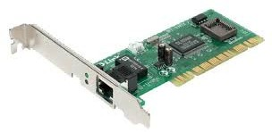

6 | Bridge | - Connects two networks segments  - Filters and forward data packets  - Reduces network collisions | 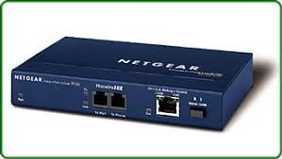
7 | Gateway | - Connects different types networks  - Translate protocols between networks  - Acts as an entry exit point | 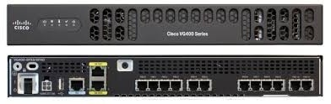
8 | Access Point | - Provides wireless network access  - Connects wireless devices to wired LAN  - Extends WI-FI coverage area | 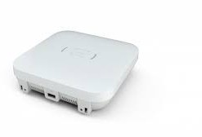
9 | Patch Panel | - Organizes and manages cables  - Provides a central connection point  - Used in network racks | 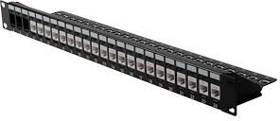
10 | Fiber Optic Converter | - Converts copper signals to fiber  - Extends network over long communication  - Reduces signal loss | 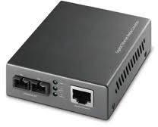

11 | HDMI cable | - Most common used for TVs and devices  - High definition multimedia interface  - Id standard for simultaneously transmitting digital video and audio from a source | 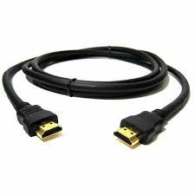
12 | Coaxial cable | - An electrical cable designed to carry high-frequency radio signals with minimal interface  - It consists four layers  - 1.copper conductor 2.dielectric insulator  - metallic shield  - outer jacket | 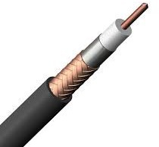
13 | Router | - Connects multiple networks together  - Router data to the correct destination  - Provides security and DHCP services | 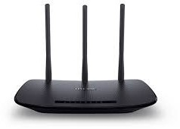
14 | Hub | - Connects multiple devices in a LAN  - Simple and easy yo use  - Used in small or basic networks | 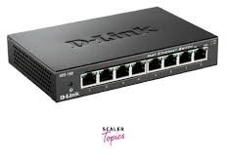
15 | Switch | - Connects multiple devices in a LAN  - Sends data only to the intended device  - Reduce network congestion | 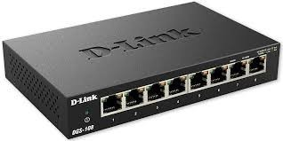

16 | Repeater | - A network device that receives weak signal  - Operates the physical layer | 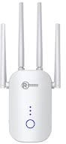
17 | VGA cable | - VIDEO GRAPHICS ARRAY CABLE  - Supports resolution up to 2048*1536 | 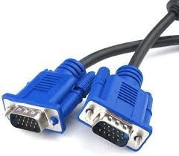
18 | USB Type-A cable | - The standard rectangular USB connector used for data transfer and power delivery between computers  - It supports USB 2.0 and 3.0 standards | 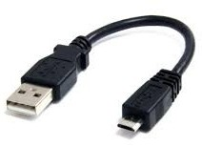
19 | USB Type-C cable | - A reversible,oval-shaped USB connector supporting data transfer  - Now the universal standard across laptops smartphone tablets | 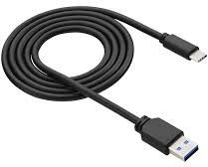
20 | Crossover cable | - It connects computer to computer switch to switch  - Crossover cables should not be used to connect “unlike” devices | 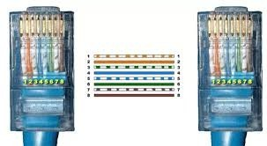

21 | Satellite Modem | - Provides satellite internet  - Used in remote areas  - Wide network coverage | 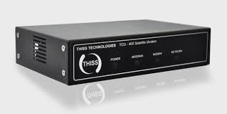
22 | Load Balancer | - Ensure availability  - Improves speed  - Distributes network traffic | 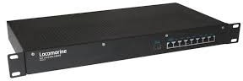
23 | Media Converter | - Converts cable types  - Extends network distance  - Supports fibre connection | 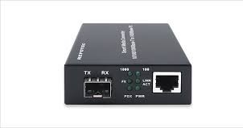
24 | Network Extender | - Extends WI-FI range  - Easy to install  - Improves signal strength | 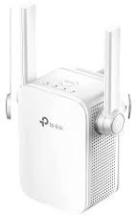
25 | Smart Hub | - Connects smart devices  - controls home appliances  - Supports automation | 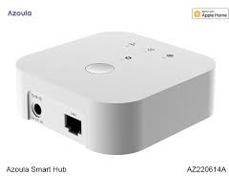

26 | CSU/DSU | - Connects WAN lines  - controls digital signals  - works with routers | 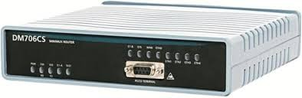
27 | SAN Switch | - Connects storage devices  - High speed transfer  - Used in data centers | 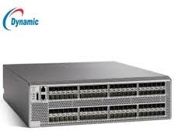
28 | VPN Gateway | - Provides secure access  - Encrypts network traffic  - connects remote branches | 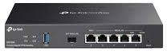
29 | Proxy Server | - Hides user IP address  - improves security  - Filter web security | 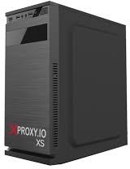
30 | KVM Switch | - Controls multiple computers  - Uses one keyboard and mouse  - Saves workspace space | 